**Budget £145,000**

**Total costs including salary + material + labour charge = £100,873**

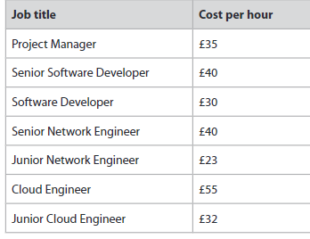

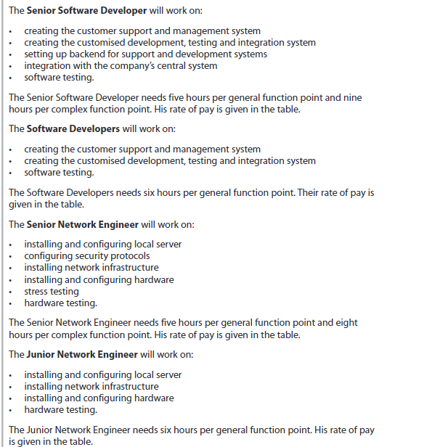

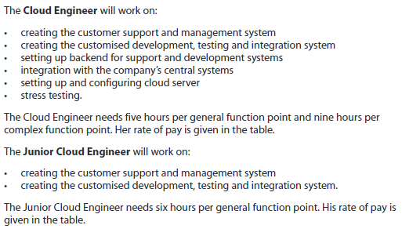

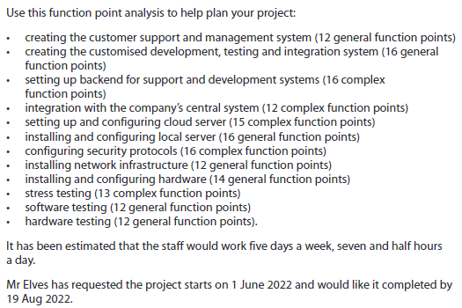

**Employee salary cost**

1. Creating customer support and management system = 12 general points

Junior cloud engineer = 6 hours per general point

12 general function points x 6 = 72

72/ 7.5 =9.6 days

72 x £32 = £2304

1. Creating customized development, testing and integration system = 16 general points

Junior cloud engineer = 6 hours per general point

16 general function points x 6 = 96

96/ 7.5 = 12.8 days

96 x £32 = £3072

1. Setting up backend for support and development system = 16 complex points

Cloud engineer = 9 hours per complex point

16 complex function points x 9 = 144

144 / 7.5 = 32 days

144 x £55 = £7920

1. Intergration with company's central system = 12 complex points

Cloud engineer = 9 hours per complex point

12 complex function points x 9 = 108

108 / 7.5 = 14.4 days

108 x £55 = £5940

1. Setting up and configuring cloud server = 15 complex function points

Cloud engineer = 9 hours per complex point

15 complex function points x 9 = 135

135 / 7.5 = 18 days

135 x £55 = £7425

1. installing and configuring local server = 16 general function points

Senior Network Engineer = 5 hours per general function point

16 general function points x 5 = 80

80 / 7.5 = 10.6 days

80 x £40 = £3200

1. configuring security protocols = 16 complex function points

Senior Network Engineer = 8 hours per complex function point

16 complex function points x 8 = 128

128 / 7.5 = 17.1 days

128 x £ 40 = £5120

1. Installing network infrastructure = 12 general function points

Junior Network Engineer = 6 hours per general function point

12 general function points x 6 = 72

72 / 7.5 = 9.6 days

72 x £23 = £1656

1. Installing and configuring hardware = 14 general function points

Senior Network Engineer = 5 hours per general function point

14 general function points x 5 = 70

70 / 7.5 = 9.3 days

70 x £40 = £2800

1. stress testing = 13 complex function points

Software developer = 6 hours per complex point

13 complex function points x 6 = 84

84 / 7.5 = 10.4 days

84 x £30 = £2520

1. software testing = 12 general function points

Software Developers = 6 hours per general function point

12 general function points x 6 = 72

72 /7.5 = 9.6 days

72 x £ 30 = £2160

1. hardware testing = 12 general function points

Junior Network Engineer = 6 hours per general function point

12 general function points x 6 = 72

72 /7.5 = 9.6 days

72 x £23 = £1656

Total = £2304 + £3072 + £7920 + £5940 + £7425 + £3200 + £5120 + £1656 + £2800 + £2520 + £2160 + £1656 = **£45,773**

**£45,773 = Salary for all employees (all working hours)**

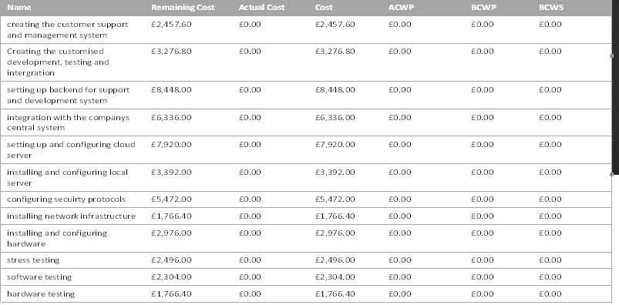

**Equipment costs**

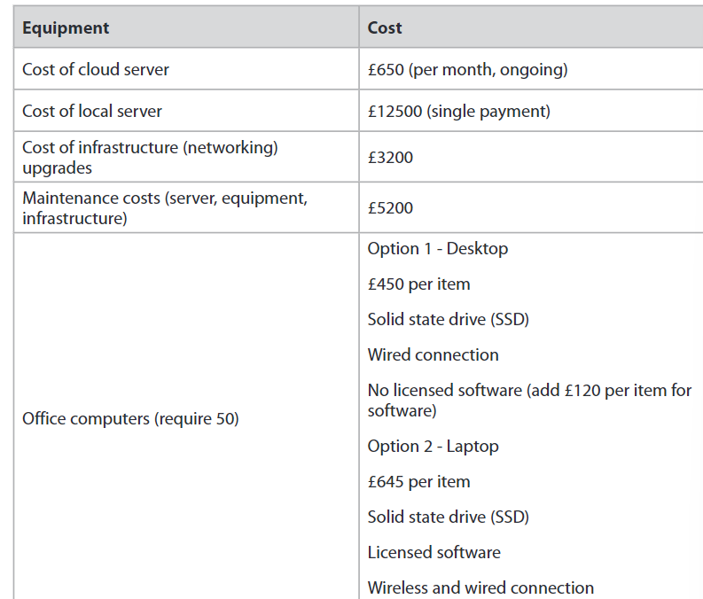

Cost of cloud server = £650 (per month)

£650 x 3 = £1950 (3 months)

Cost of local server = £12500

Cost of infrastructure = £3200

Maintenance costs = £5200

Option 2 = £645

£645 x 50 = £32250 (50 packages)

Total = £1950 + £12500 + £3200 + £5200 + £32250 = **£55,100 total material cost**

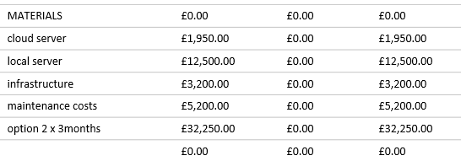

**Overall total costs = £45,773 = Salary for all employees (all working hours) + £55,100 total material cost = £ 100,873**

|  |  |  |  |  |  |  |
| --- | --- | --- | --- | --- | --- | --- |
| **Name** | **Remaining Cost** | **Actual Cost** | **Cost** | **ACWP** | **BCWP** | **BCWS** |
| creating the customer support and management system | £2,457.60 | £0.00 | £2,457.60 | £0.00 | £0.00 | £0.00 |
| Creating customized development, testing and integration | £3,276.80 | £0.00 | £3,276.80 | £0.00 | £0.00 | £0.00 |
| setting up backend for support and development system | £8,448.00 | £0.00 | £8,448.00 | £0.00 | £0.00 | £0.00 |
| integration with the company's central system | £6,336.00 | £0.00 | £6,336.00 | £0.00 | £0.00 | £0.00 |
| setting up and configuring cloud server | £7,920.00 | £0.00 | £7,920.00 | £0.00 | £0.00 | £0.00 |
| installing and configuring local server | £3,392.00 | £0.00 | £3,392.00 | £0.00 | £0.00 | £0.00 |
| configuring security protocols | £5,472.00 | £0.00 | £5,472.00 | £0.00 | £0.00 | £0.00 |
| installing network infrastructure | £1,766.40 | £0.00 | £1,766.40 | £0.00 | £0.00 | £0.00 |
| installing and configuring hardware | £2,976.00 | £0.00 | £2,976.00 | £0.00 | £0.00 | £0.00 |
| stress testing | £2,496.00 | £0.00 | £2,496.00 | £0.00 | £0.00 | £0.00 |
| software testing | £2,304.00 | £0.00 | £2,304.00 | £0.00 | £0.00 | £0.00 |
| hardware testing | £1,766.40 | £0.00 | £1,766.40 | £0.00 | £0.00 | £0.00 |
|  | £0.00 | £0.00 | £0.00 | £0.00 | £0.00 | £0.00 |
|  | £0.00 | £0.00 | £0.00 | £0.00 | £0.00 | £0.00 |
| MATERIALS | £0.00 | £0.00 | £0.00 | £0.00 | £0.00 | £0.00 |
| cloud server | £1,950.00 | £0.00 | £1,950.00 | £0.00 | £0.00 | £0.00 |
| local server | £12,500.00 | £0.00 | £12,500.00 | £0.00 | £0.00 | £0.00 |
| infrastructure | £3,200.00 | £0.00 | £3,200.00 | £0.00 | £0.00 | £0.00 |
| maintenance costs | £5,200.00 | £0.00 | £5,200.00 | £0.00 | £0.00 | £0.00 |
| option 2 x 3months | £32,250.00 | £0.00 | £32,250.00 | £0.00 | £0.00 | £0.00 |
|  | £0.00 | £0.00 | £0.00 | £0.00 | £0.00 | £0.00 |